Phase : I

Register Number : 19BCE2119

Name : Gaurav Kumar Singh

EPJ Slot : L13+L14

Project Title : Cement Industry Project Management System

Mobile Number(team leader) : 9664395951

Project type : Application

**Review-1**

**CEMENT INDUSTRY PROJECT MANAGEMENT DATABASE**

Cement Manufacturing is the infrastructure of establishing many other infrastructures. As important as it is, its also a very complex process to manufacture cement. Sourcing and mining of limestone and other ores, clinker manufacturing, to mixing and packaging, a lot of raw materials, sourcing and machineries are involved. Because of all this the units and projects have to established in several different parts of the country or even world and to keep track of everything can often get confusing but also plays important role since everything is unit plays an important role for the manufacturing process. To reduce this confusion, DBMS can be used to reduce overall complexity and make it easier and faster for us to access the data when needed, increasing our overall efficiency.

**ENTITY-RELATIONSHIP DIAGRAM**

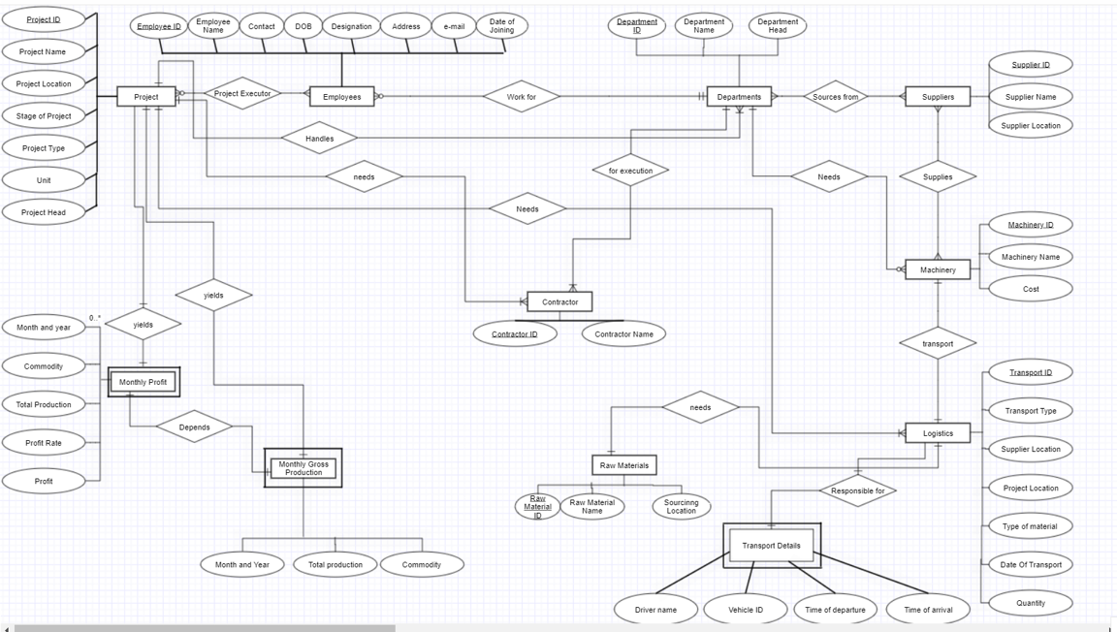

**CONCEPTUAL SCHEMA**

**PROJECT**

Project_ID, Project_Name, Project_Location, Stage_of_Project, Project_Type, Unit, Project_Head

**EMPLOYEES**

Emp_ID, Emp_Name, Contact, DOB, Designation, Address, E-mail, Date_of_Joining, Project_ID, Dept_ID

**DEPARTMENTS**

Dept_ID, Dept_Name, Dept_Head, Project_ID

**SUPPLIERS**

Supplier_ID, Supplier_Name, Supplier Location

**MACHINERY**

Machinery_ID, Machinery_Name, Cost, Supplier_ID

**RAW MATERIALS**

Raw_Material_ID, Raw_Material_Name, Unit, Cost per unit

**LOGISTICS**

Tran_ID, Trans_Type, From, To, Mat_ID, Quantity

**CONTRACTOR**

Contractor_ID, Contractor_Name, Project_ID, Dept_ID

**MONTHLY PROFIT**

Month_and_Year, Project_ID, Commodity, Total_Production, Profit_Rate, Profit

**TRANSPORT DETAILS**

Driver_Name, Vehicle_ID, Date_and_Time_of_Departure, Date_and_Time_of_Arrival, Trans_ID